**AI ASSISTED CODING**

**LAB-1*: Environment Setup – GitHub Copilot and VS Code Integration***

**Roll No:** 2503A51L07

**Name:** Bathini Sahasra

**Batch:** 24BTCAICSB19

**Task-1 Description:** Write a comment: # Function to check if a string is a valid palindrome (ignoring spaces and case) and allow Copilot to complete it

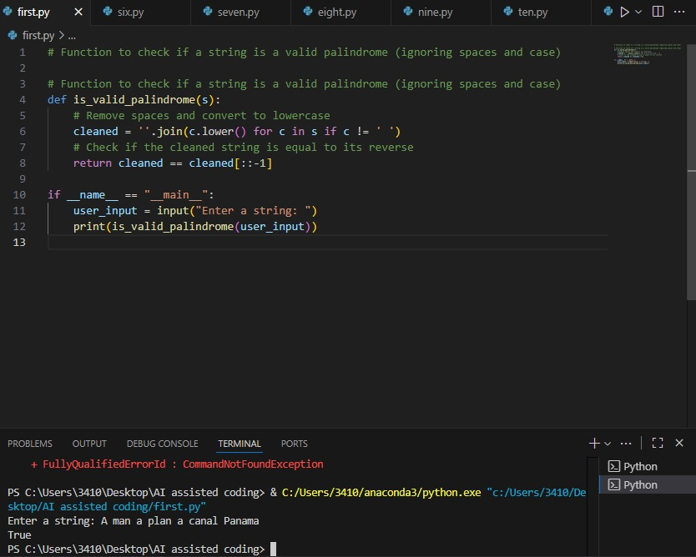**Prompt:** Generate a comment: # Function to check if a string is a valid palindrome (ignoring spaces and case) and complete it.

**Observation:** In Task 1, I observed that a simple comment describing the functionality (checking if a string is a palindrome) was enough for Copilot to generate a correct implementation with case and space handling.

**Task-2 Description:** Generate a Python function that returns the Fibonacci sequence up to n terms. Prompt with only a function header and docstring

**Prompt**: Generate a Python function that returns the Fibonacci sequence up to n terms. The function should include only the function header and a detailed docstring and should implement with example and also check by asking inputs from user.

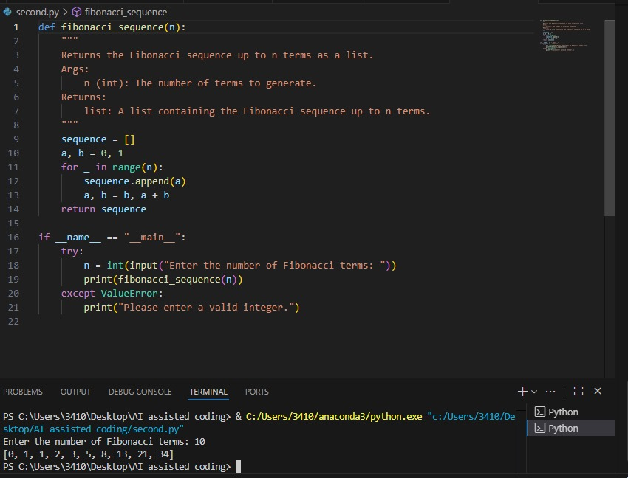**Code Generated:**

**Output:**

**Observation:** In Task 2, providing only a function header and docstring for generating the Fibonacci sequence highlighted how Copilot understands documentation and converts it into working logic.

**Task-3 Description:** Write a comment like # Function to reverse a string and use Copilot to generate the function.

**Prompt:** Write a comment like # Function to reverse a string and generate the function.

**Code Generated:**

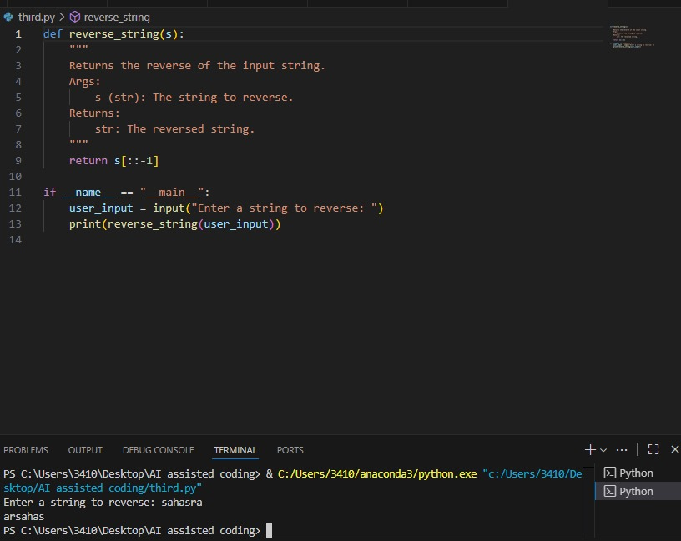

**Observation:** In Task 3, a short comment about reversing a string allowed Copilot to create a concise and accurate function, showing its ability to handle basic operations efficiently.

**Task-4 Description:** Generate a program that simulates a basic calculator (add, subtract, multiply, divide). Write the comment: # Simple calculator with 4 operations and let AI complete it.

**Prompt:** Write the comment: "# Simple calculator with 4 operations" and let AI complete it. The program should be a fully working calculator with input/output and operator selection logic, supporting add, subtract, multiply, and divide operations.

**Code Generated:**

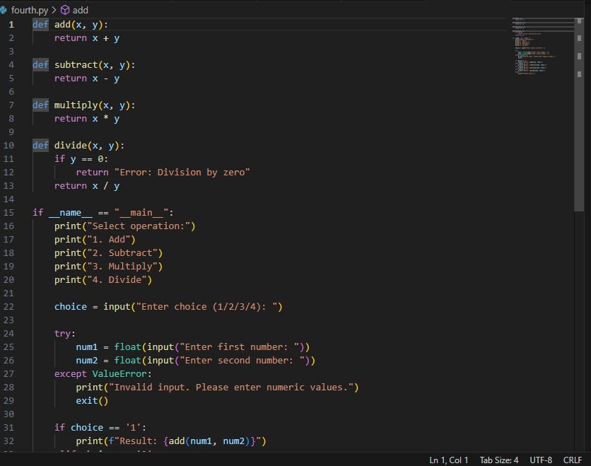

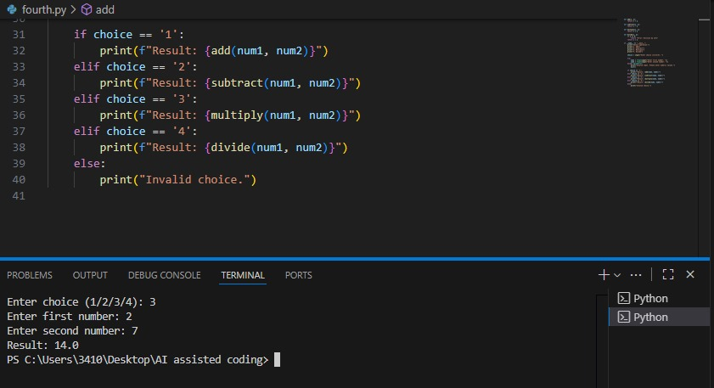

**Observation:** In Task 4, using a comment to describe a “simple calculator with four operations” led Copilot to produce a fully functional program with input handling and operator selection, proving its capability to generate interactive applications.

**Task-5 Description:** Use a comment to instruct AI to write a function that reads a file and returns the number of lines.

**Prompt:** Write a comment instructing AI to write a function that reads a file and returns the number of lines.

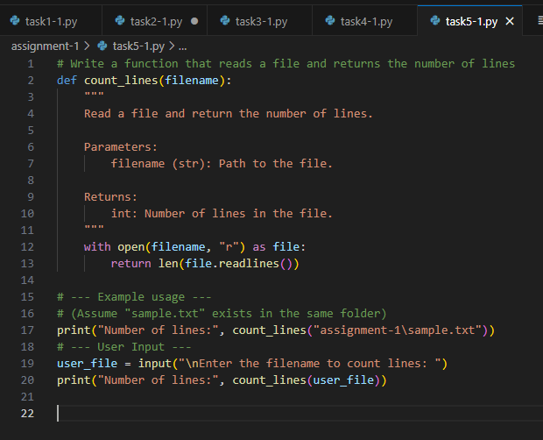**Code Generated:**

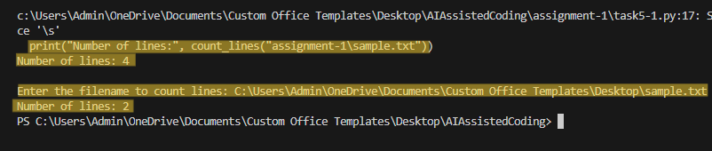

**Output:**

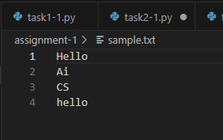

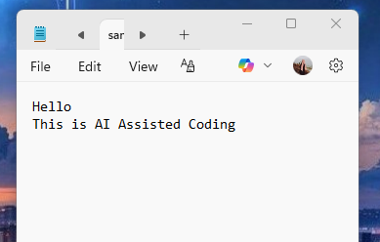**Observation:** In Task 5, Copilot was able to generate file-handling logic from a single comment, showing its usefulness in automating repetitive tasks like counting lines in a file.